Csaba Palosi 30/11/2025

TU885
Application Security:
Assignment 1
Development of a Security Tool

Contents
1. Introduction 2
2. Libraries used in the Application 2
3. Application Overview 3
4. Code Structure and Function Descriptions 5
5. Case examples 6
6. Error Handling, Robustness and Security 9
7. Conclusion 9
8. Appendix for the complete function list 9
9. References 10

1. Introduction
This project purpose was to create an application implemented by an AI-powered phishing detection tool based on Python. The application is able to analyse email text and determine whether the email is likely to be a phishing attempt or not. The system supports two methods:
- Local Keyword Analysis: local scan that looks for common phishing words used by malicious attackers such as “password”, “verify”, “urgent”, “reset”, “invoice”, etc.
- OpenAI GPT Analysis: online OpenAI’s GPT model to generate a confidence score and an explanation of whether the email appears malicious or not.
The application also uses an authentication system, including registration, login and optional account deletion. After logged in users can analyse email files stored on their system.
As required by the assignment, the entire application is implemented in one Python (.py) file but it is organised using reusable functions to maintain readability and structure.

2. Libraries used in the Application
Python built-in libraries and external ones were also used during the coding phase. Built-in modules require no installation while external ones must be installed using pip.

2.1 Built-in Python Libraries
These libraries come with Python as pre-configured, so no installation is needed:
Libraries (pre-configured):
- os (file path operations and environment variable handling)
- json (reading and saving user accounts to a JSON file)
- re (username validation using regular expressions)
- string (removing punctuation during text cleaning)

2.2 External libraries (installation is needed):
These libraries must be installed manually because they are not pre-configured in Python:
- bcrypt (secure hashing of user passwords)
- python-dotenv (loads the OpenAI API key from a .env file)
- openai (sends email text to the GPT model for phishing analysis)

command to install external libraries:
pip install bcrypt python-dotenv openai

3. Application Overview
The tool performs phishing detection by doing it locally (offline) or using GPT (online).
3.1 Local Keyword-Based Analysis:
- clean the scanned email text by removing punctuation and converting it into a lowercase string
- scan for predefined suspicious keywords
- generate a “suspicious score” based on how many suspicious keywords found
- if the email contains more than 2 suspicious keywords it is flagged as a phishing email

This scan is simple, fast and works if there is no internet access on the computer.

3.2 GPT/OpenAI Analysis
The tool sends the email text to OpenAI’s GPT model.
GPT provides:
- a phishing classification
- a confidence score
- a detailed explanation

This gives a much deeper analysis than simple keyword detection.

3.3 User Authentication
The authentication system provides the user to do the following:
- register for a new user with a bcrypt-hashed password
- login after the username and password are verified
- delete the user account from the system
- logout from the application

3.4 File Handling
Users can input text file paths such as:
- samples/malicious_email.txt (preconfigured)
- samples/normal_email.txt (preconfigured)
- etc.

The tool loads the file content, handles missing files and ensures its safe reading.

3.5 Report Output
Both analysis methods generate clear reports.
Example of a local scan report:
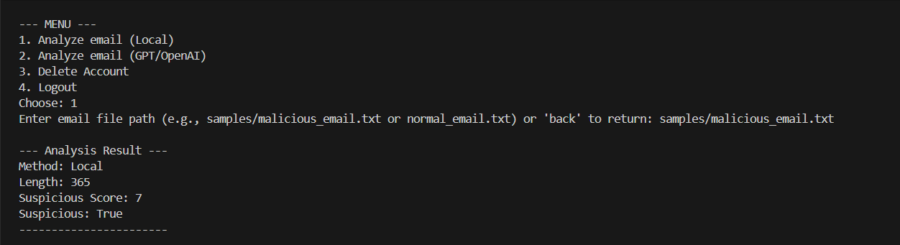

Example of GPT scan report: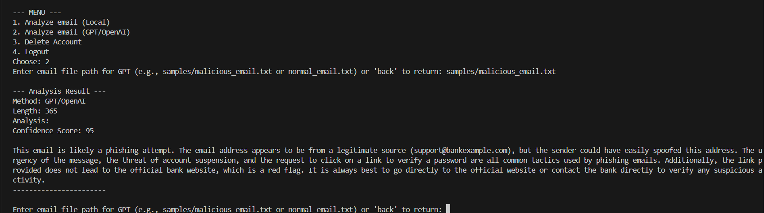

4. Code Structure and Function Descriptions
The assignment required everything to be in one .py file and the program follows good modular design, coding design and creation of functions in order to avoid repetition.

4.1 User and Password Functions
- hash_password(password) - uses bcrypt to securely hash passwords
- verify_password(password, hashed) - validates passwords
- save_users(users) - saves all users to users.json
- load_users() - loads users from JSON
- delete_user(username) - removes a user account

4.2 Email Handling
- load_email(path) - loads email text from a user-specified file path
- handles errors like missing files or unreadable paths

4.3 Local Phishing Analysis
- clean_text(text) - removes punctuation and normalises text
- analyze_email_local(email_text) - checks for suspicious keywords

4.4 GPT/OpenAI Phishing Analysis
- analyze_email_gpt(email_text) - sends the text to GPT and returns a detailed result
- handles API key errors and exceptions

4.5 Report Function
- print_report(result) - displays the results in a readable format

4.6 User Interface
- register() - collects and validates new user data
- login() - checks credentials
- user_menu() - main menu after authentication
- main() - entry point of the program

5. Case examples
Case 1: login new user without registration
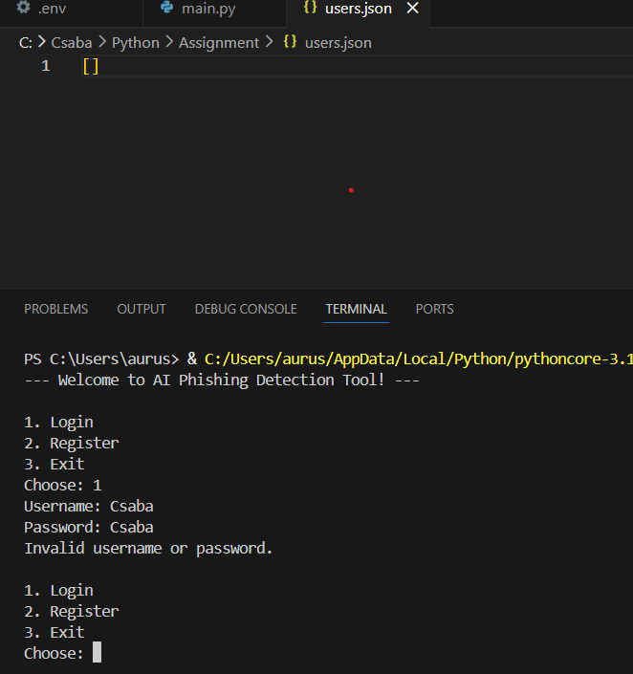

Case 2: register new user and login
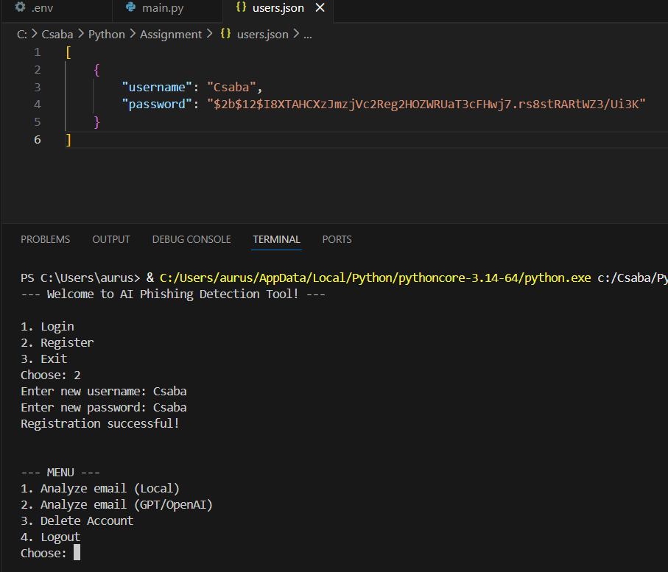
Case 3: analyze email (local)
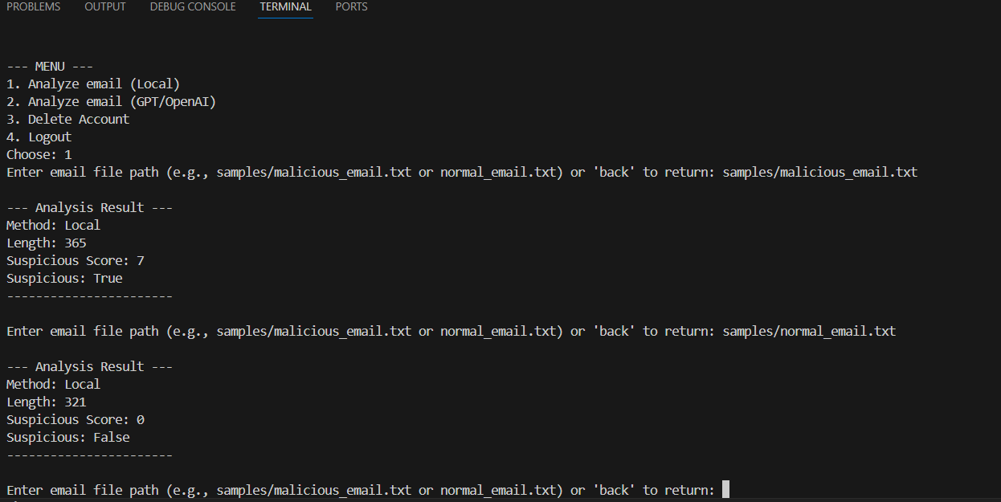
Case 4: analyze email (online - GPT)
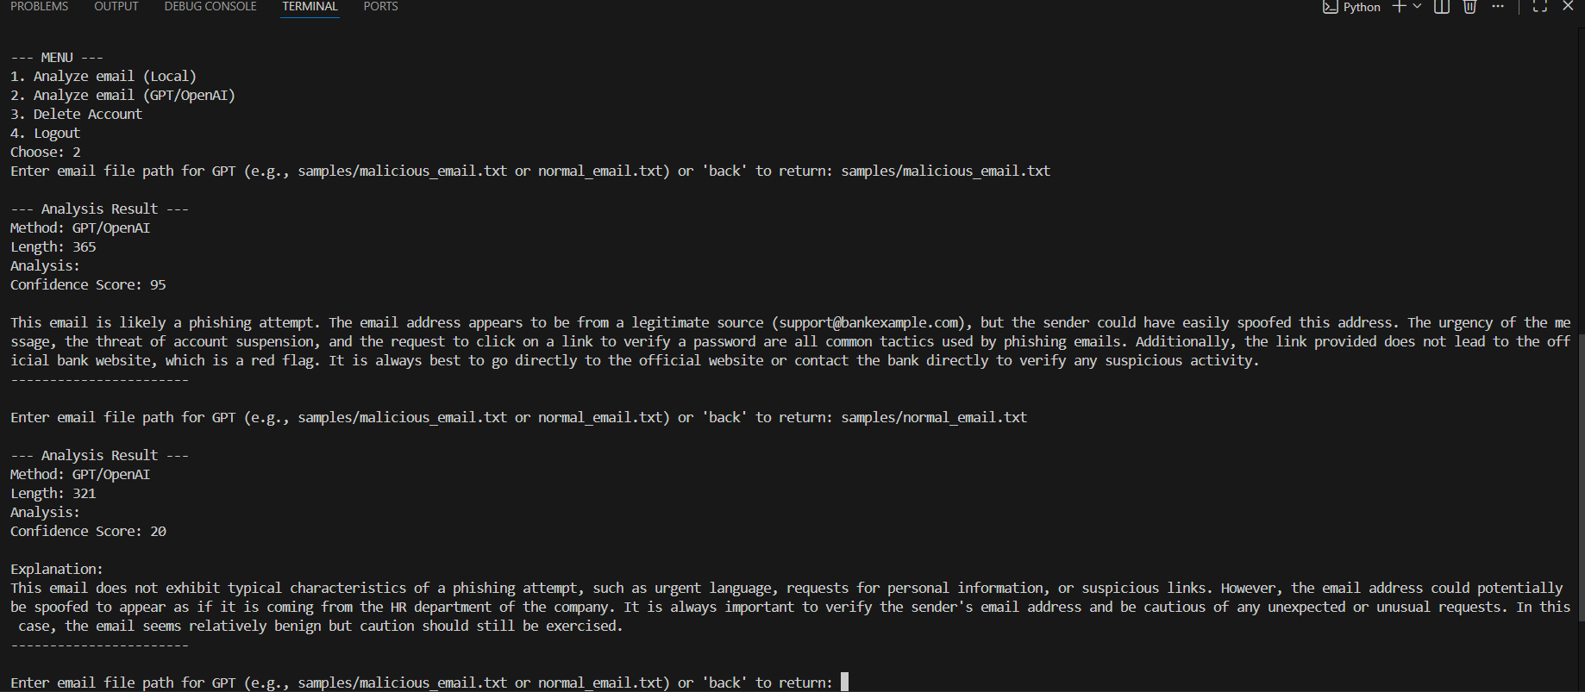

Case 5: delete account
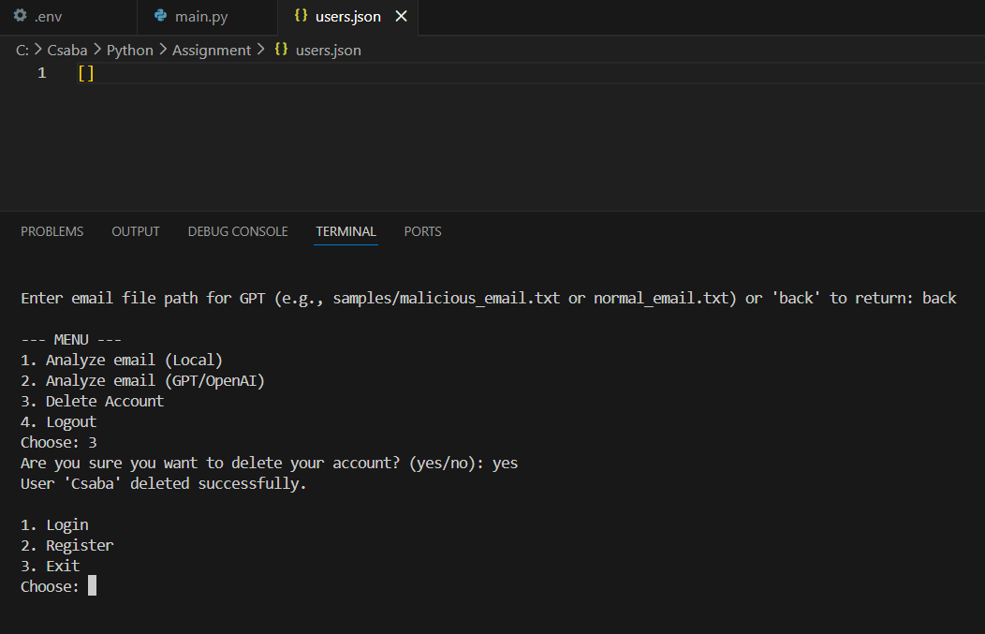

6. Error Handling, Robustness and Security
The application uses several secure programming practices:
- password security by hashing it (bcrypt)
- API key protection using .env
- username and password validation
- defensive file handling
- try/except to call GPT API
- functions for good coding practices
- prevention of plaintext credential storage

These measures improve reliability and security, aligning with good application security principles.

7. Conclusion
This project demonstrates a fully functional phishing detection tool with a local keyword and an online AI-based analysis. It contains authentication, secure password storage, API interaction, file handling and structured reporting. The application showed us that GPT/OpenAI is an effective tool against cyber-attacks such as the demonstrated phishing threats.

8. Appendix for the complete function list
- hash_password(password)
- verify_password(password, hashed)
- save_users(users)
- load_users()
- delete_user(username)
- load_email(path)
- clean_text(text)
- analyze_email_local(email_text)
- analyze_email_gpt(email_text)
- print_report(result)
- register()
- login()
- user_menu()
- main()

9. References
Python (21/11/2025): https://docs.python.org/3/library/
bcrypt (21/11/2025): https://pypi.org/project/bcrypt/
python-dotenv (21/11/2025): https://pypi.org/project/python-dotenv/
OpenAI API (21/11/2025): https://platform.openai.com/docs/
OWASP (21/11/2025): https://owasp.org/
NIST (21/11/2025): https://www.nist.gov/

